Information Literacy Skills and Inquiry Process
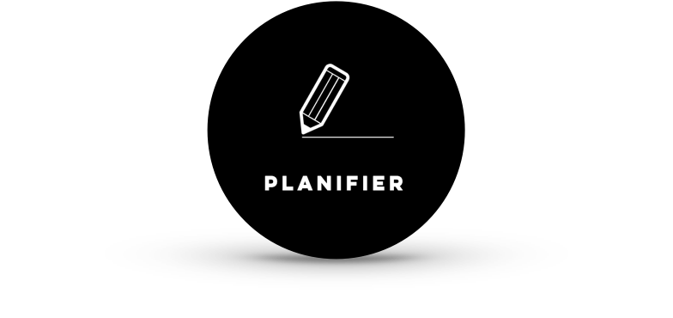  What is asked of me? | - I plan my work.  - I define my information needs.  - I find the heart of the question.  - I define the topic.  - I get familiar with the theme of the research.  - I find keywords.  - I think or find synonyms.  - I keep in mind the purpose of the research.
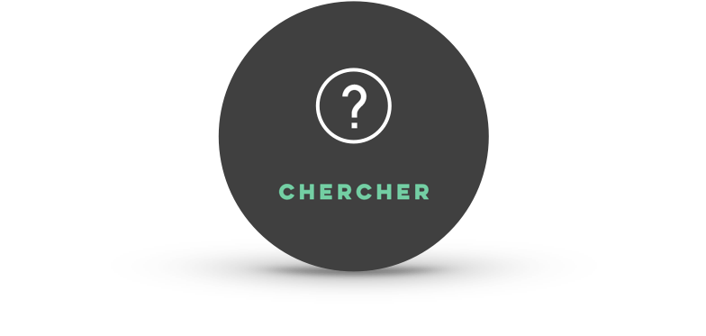  Where can I find information? | - I search various sources of information.  - I determine which source is the most pertinent.  - I write my research keywords in a search engine, a library catalogue or a database (using, if necessary, Boolean operators or advanced search parameters).  - I reformulate if needed.  - I keep traces of the sources and documents that seem most pertinent.  - I use different modes of research (facets).  - I use bibliographies to focus my research..
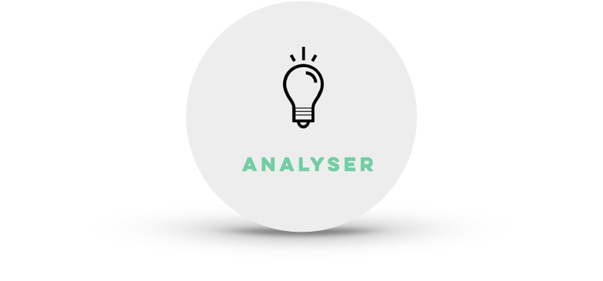  How do I select sources? | - I evaluate the pertinence and credibility of my chosen sources.  - I select the sources that are accessible.  - I choose the sources that answer your topic.  - I triangulate the information found with other sources.  - I use the trace and evaluation form.
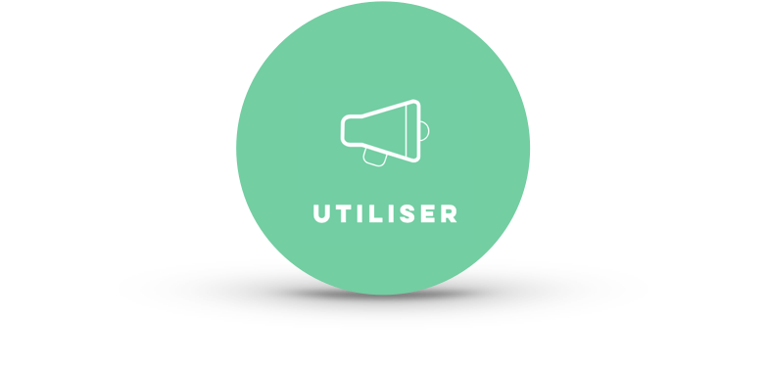  Can I copy and paste? | - I can copy-paste pertinent information and keep the reference to my source of information  - I reformulate what I copy-pasted and still keep the reference to my source of information.  - I take notes on my reading or listening of my information source and I keep its reference. J  - I keep traces of all the information gathered.  - I organize my information according to my topic and research question.

Sandra Laine, inspiré des tableaux produits par Rachel DeRoy-Ringuette et les travaux du Comité des compétences informationnelles en bibliothèque scolaire - Ressource créée pour l’autoformation : Développer ses compétences informationnelles

