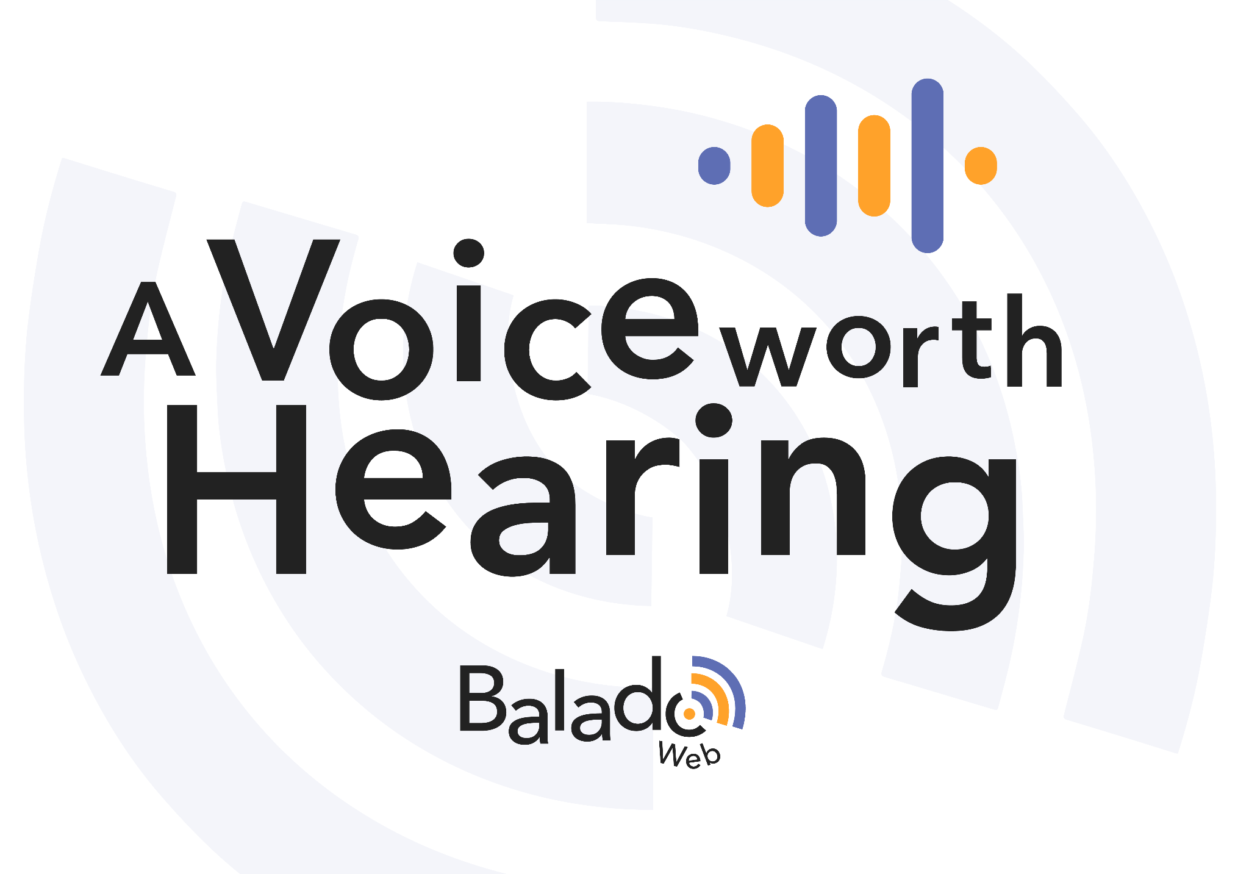
Criteria for posting a podcast

Before you post, check these criteria and modify your podcast accordingly.

Category | Criteria | Comments
Quality of the content | The content of the podcast allows people to quickly grasp the subject.
 | The content is created with the audience in mind.
 | The content of the podcast is accessible and reflects the quality of the language (prosodic elements).
 | The podcast has acceptable sound quality: the voice and music are well balanced, the volume is constant, no feedback, etc.
Rules and responsibilities | Images, sound clips and quotes respect copyright. Any required authorizations should be mentioned in the description of the podcast.
 | The content respects the rights and integrity of individuals (no racist, sexist or damaging comments, etc.).
 | The content does not disclose personal information (last name, phone number, address, etc.).

