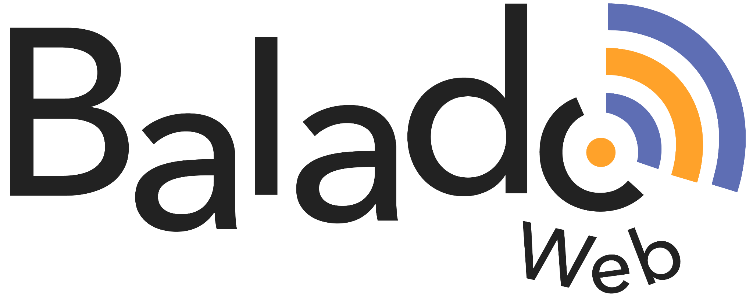
Storyboard (adapt to your needs)

 | Text | Audio | Images
Musical and/or spoken opening signature
(intro)

Introducing the topic
Subject (body)
Conclusion
Musical and/or spoken closing signature (outro)

